Auto KJ 60 Day Trial Signup Guide
  - Create your account and activate Full version
Website rechecked 14 October 2026 • Desktop instructions for version 1.30.0
Start by creating a free Auto-KJ account, then activate the trial inside the desktop app on the computer you will use. This guide takes you through the website, the email check, the trial agreement and the confirmation screen.
The 60 days begin only when you successfully activate the trial. Creating an account, downloading the app or verifying your email does not start the clock.
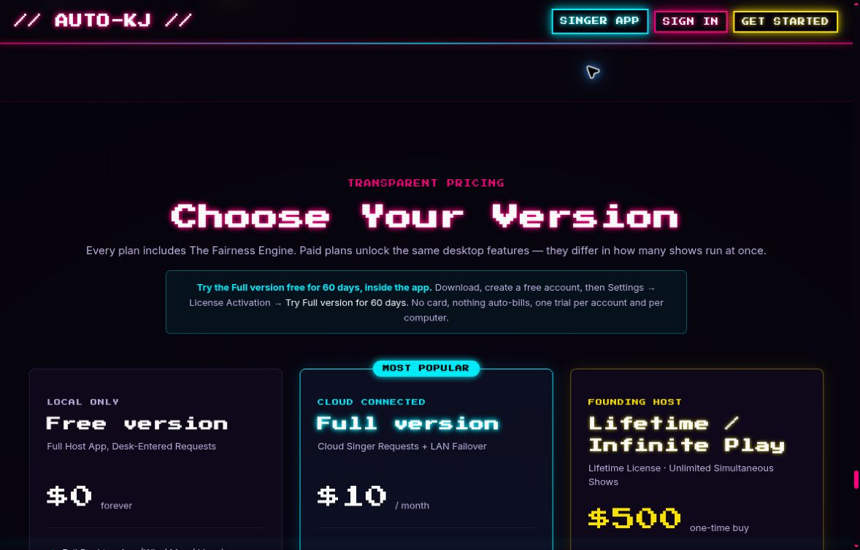
The public pricing page explains that the free trial starts inside the desktop app.

Before you begin
- Use a computer you intend to keep using for the trial and an email inbox you can open now.
- Keep the computer online for account sign-in, email verification and activation.
- Allow time to finish the email check: the verification code expires after 15 minutes.
- The trial requires no payment card and does not automatically bill you. It is limited to one eligible account and one recognized computer.
If you already have an account, use it. If the desktop app is already installed, go straight to “Open the trial form” on page 5.

Open the account form
1. Visit the official website. Open auto-kj.com in your browser.
Open the Auto-KJ website
2. Click GET STARTED. This currently opens a window titled PLAYER SELECT. That is the sign-in window.
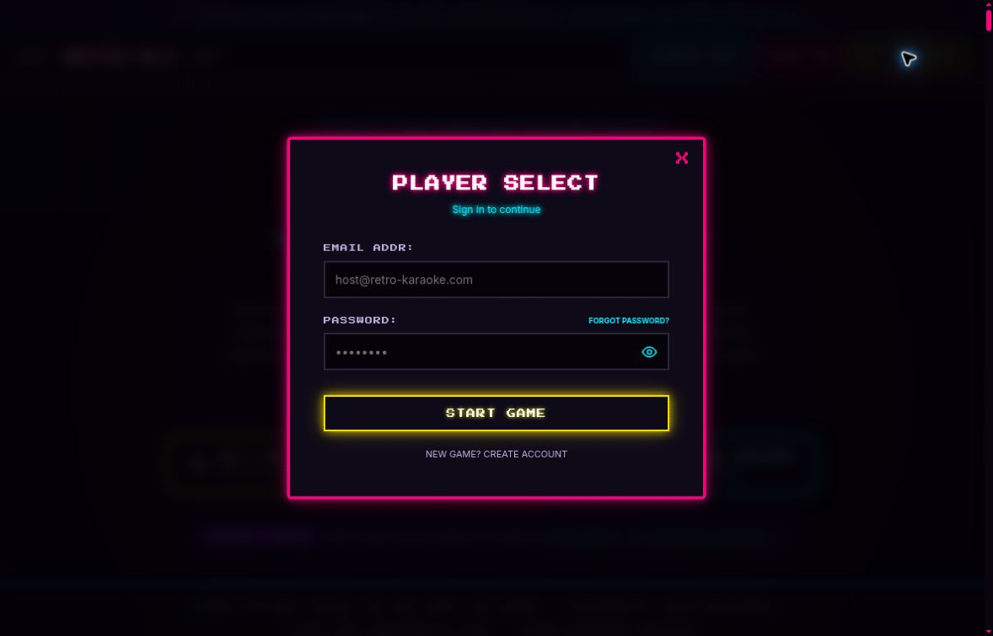
Website sign-in window. NEW GAME? CREATE ACCOUNT is the small link below START GAME.
3. Choose the route that matches you. For a new account, click NEW GAME? CREATE ACCOUNT below the large START GAME button. Continue on page 3.
Already have an account? Enter your email in EMAIL ADDR and your existing password in PASSWORD, then click START GAME. Continue to the download instructions on page 4.
4. If you forgot your password, reset it first. Enter your account email and use FORGOT PASSWORD? on this sign-in screen. Follow the reset instructions, then return and sign in.

Use your account password
Choose your own password when creating a new account. Use that same password whenever you sign in. A permanent License Key and an emailed trial verification code are separate credentials; neither belongs in the PASSWORD field.
The screenshots show empty fields with the website’s example text and password dots. Enter your own information; the example email address is not an account to use.

Create your free account
The window should now say CREATE CHARACTER and “Create your account.” If it still says PLAYER SELECT, return to step 3 and select the small create-account link.
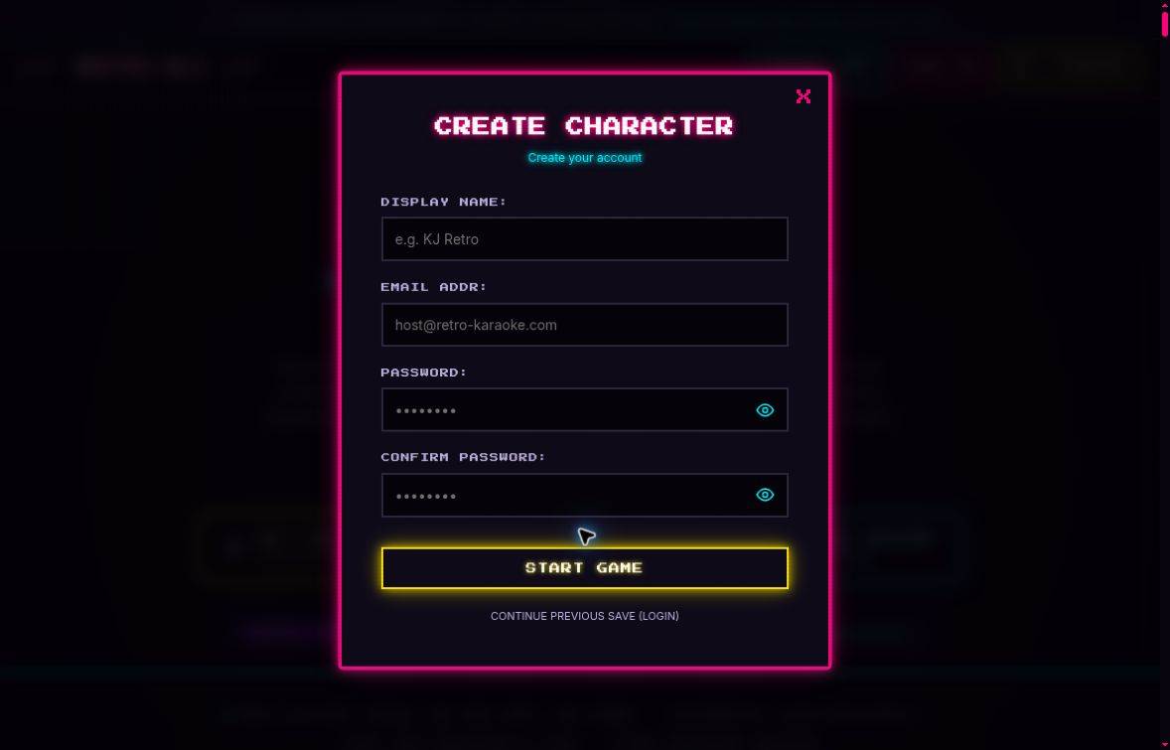
Website account-creation window. START GAME submits the account details after you confirm your password.
5. Enter your DISPLAY NAME. Use the name you want associated with your Auto-KJ account.
6. Enter your EMAIL ADDR. Use an address you control and can open now. Check the spelling carefully; this address will receive your trial verification email.
7. Choose your PASSWORD. Enter a unique account password with at least 8 characters. Save it securely. The account password has a maximum size of 128 bytes; non-English characters and emoji can use more than one byte each.
8. Confirm your password. Enter exactly the same password again in CONFIRM PASSWORD. If you need to check what you typed, use the eye icon inside either password field, then hide the password again when finished.
9. Click START GAME. A successful registration signs you into a Free account. Your 60-day trial has not started yet.

After you create the account
Keep your email address and password available for the desktop trial form. You may also see a permanent LICENSE KEY in the website dashboard or welcome email. The password sign-in route in this guide does not require copying that key.
A welcome email or a visible license key confirms an account exists. You will confirm the trial separately inside the desktop app in step 24.

Download and open Auto KJ
10. Open the pricing section. On auto-kj.com, find the Free version card and its Download App (Free) section.
Open the official download choices
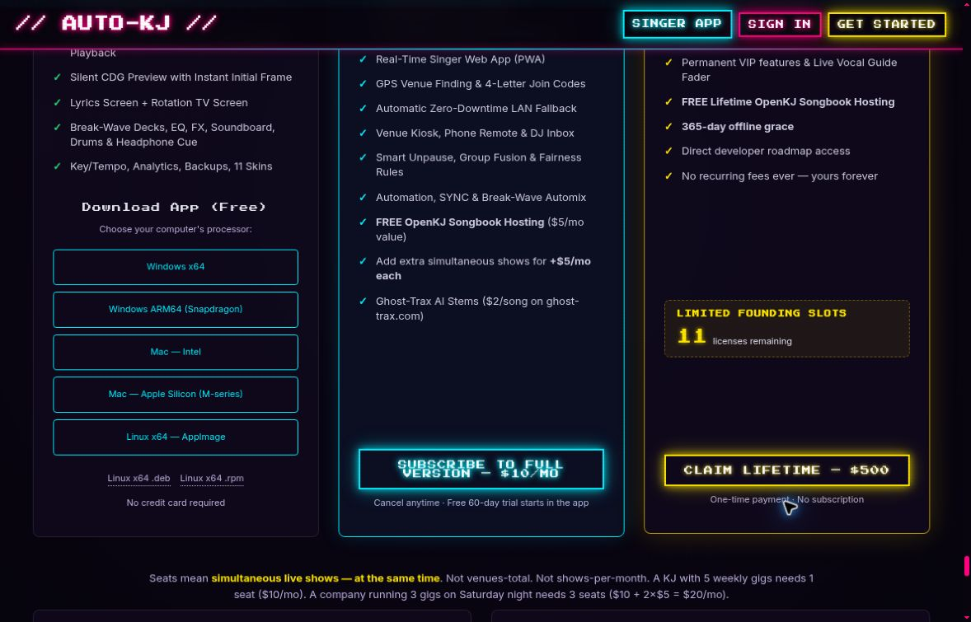
The free download buttons are in the left-hand card. The Full version subscription button and the Full version, paid once, button are separate purchases.
11. Choose the download for your computer. Match both the operating system and processor. If you are unsure, check your computer’s system information before downloading.
- Windows: Windows x64 for a 64-bit Intel or AMD PC; Windows ARM64 (Snapdragon) for an ARM-based PC.
- Mac: Mac — Intel for an Intel Mac; Mac — Apple Silicon (M-series) for a Mac with an M-series chip.
- Linux: Linux x64 — AppImage, or the .deb or .rpm package appropriate for your distribution.
12. Install and open the downloaded app. Follow the installer or package instructions for your operating system. Start Auto-KJ after installation. The desktop app hosts the trial; the Singer App button opens a different app.
Use the free download for this walkthrough. The Full version subscription and the Full version, paid once, are separate purchases and are not needed to start the no-card trial.
If your operating system blocks or warns about the installer, verify the file came from auto-kj.com and consult the official manual or support before proceeding.

Open the trial form
Choose the path that matches what you see. Both paths lead to the same account sign-in and trial verification form.

On your first launch
13. Start the setup wizard. Choose Set up my show.
14. Choose the Full version or the trial. Select the Full version or the free 60-day trial.
15. Choose the trial. Under “Do you already have a license key?”, click Start my free 60-day trial. If you still need an account, use the website link, create it, then return here.

If Auto KJ is already installed
Open Settings, then find 🔑 License Activation. Click Try Full version for 60 days. The license section is near the top when unlicensed and can appear lower down when a license is already present.
If the trial option is missing, update an older installation using the official download. You do not need to reinstall an up-to-date app just to begin a trial.

Sign in to the trial panel
16. Enter Account email and Account password. Use the same email and password you entered on the website. Account password takes your website PASSWORD.
17. Click Sign in. Wait for the next set of trial controls to appear. This sign-in step does not start the 60 days.
Label you see | What to use | Where it belongs
PASSWORD / Account password | The password you chose when creating the account. | Website sign-in or Account password in the trial panel.
Email verification code | The full 64-character code from the trial verification email. | Email verification code, after Send verification code.
LICENSE KEY / Existing license key | Your permanent account key, available in the dashboard or welcome email. | Optional trial sign-in using Use an existing license key.

Optional key sign-in: Use an existing license key replaces the password field with Existing license key. Use your account email with that permanent key. The remaining email verification and consent steps still apply.
The ordinary Activate License form is a separate route. Use the trial panel to start the free trial, and never enter your account password into a License Key field.

Verify your email and start the trial
18. Click Send verification code. Do this inside the desktop trial panel after signing in. Leave Auto-KJ open while you check your inbox.
19. Open the verification email. Look for the subject “Verify your Auto-KJ email.” If it is missing, check spam or junk and confirm you signed in with the correct email address.
20. Copy the entire code. It is a 64-character string made of lowercase letters a–f and digits 0–9. Copy the complete string, without adding spaces or leaving off the end. It is not a short six-digit code.
21. Verify the code in Auto KJ. Paste it into Email verification code, then click Verify email. Wait until the panel says Email verified.

Timing and resend rules
- A code is valid for 15 minutes. If it expires, request another and use the newest email.
- You can resend once every five minutes. Repeated clicks during the cooldown will not speed up delivery.
- Verify email stays disabled until the entry has the expected 64-character format. Remove accidental spaces at the beginning or end.

Read the device recognition disclosure
22. Review the retention information shown in the panel. The service supplies the number of days for which its trial-recognition records are kept. Read the duration displayed in your app before agreeing.
The disclosure explains that deleting your account removes the account trial record, while coded email and device identifiers remain until the stated number of days after activation, then are removed by hourly cleanup. These records prevent repeat trials even after account deletion. It says no raw device identifier or IP address is retained for this trial-recognition record. Contact support about shared-computer exceptions.
Use the actual duration displayed in your app. If Auto-KJ says the server has not supplied its retention policy, stop and contact support; the trial cannot be started until that service issue is resolved.
23. Consent and start when you are ready. Tick the checkbox with this wording, then click Start my 60-day trial:
“I agree to device recognition and to start the fixed 60-day trial now, with no card or automatic billing.”
Successful activation begins the fixed 60-day period immediately. There is no payment-card form or checkout in this process.

If you have already started this trial
After signing in, use Check existing trial to retrieve the trial already associated with this account and computer. It restores the original deadline; it does not begin a new 60 days.

Confirm that the trial is active
24. Check the desktop confirmation. Look for the active-trial message and the end date inside Auto-KJ. Do not stop at the welcome email, email-verification message or website dashboard.
Where you are | What successful activation looks like
Trial panel | Ends [your local date and time] — this deadline never restarts. A Refresh trial status control is available.
Desktop status message | Full version trial active. No card or automatic billing; the original deadline is unchanged.
First-run setup wizard | Trial active — Full version until [date]. Next becomes available.

25. Note your displayed end date. The trial lasts 60 consecutive days, or 1,440 elapsed hours, from successful activation. It is not 60 days of usage. Refreshing, reinstalling or changing accounts does not restart it.
26. Continue your setup. If you are in the first-run wizard, click Next to reach Your songs and choose your karaoke folder. Follow the remaining setup steps for your show.

What the trial includes
The trial enables Full version on the activation computer, with one simultaneous live show. It does not include bundled songs, paid add-ons or paid Ghost-Trax credits. Have your own properly licensed karaoke files ready for show setup.

Using the trial offline
Internet access is required to sign in, send and verify the email code, activate the trial and refresh its status. A successfully cached trial can work offline until its original end time. Going offline does not extend the deadline.

When the 60 days end
Auto-KJ returns to Free version. Your library and show data are preserved, and audio already playing is allowed to continue. Full-version trial controls become unavailable, including when offline; hosting and automation end.
The no-card trial does not convert itself into the Full version, so there is no cancellation deadline to avoid a trial charge. If you want to keep Full version after the trial, choosing the Full version is a separate action. Any subscription you already purchased remains separate from this trial process.

Your completion check
- The desktop app says the trial is active.
- The desktop app displays a specific end date and time.
- You can continue the setup wizard or return to your show in Auto-KJ.

Fix account and email problems

GET STARTED asks for a password
You are looking at the sign-in window. Click NEW GAME? CREATE ACCOUNT to make a new account. In CREATE CHARACTER, choose a PASSWORD and repeat it in CONFIRM PASSWORD. The two entries must match before you can create the account.

The website says the email is already registered
Use your existing account rather than creating another. Switch back with CONTINUE PREVIOUS SAVE (LOGIN), then sign in. If needed, enter your email and select FORGOT PASSWORD? to reset the password.

The desktop rejects my password
Check that Account email is the address you registered. Account password takes the password you chose on the website. Check for typing or copy-and-paste errors. A permanent license key and an emailed verification code are different credentials.

I cannot find the verification email
First make sure you clicked Send verification code in the desktop trial panel. Check the inbox and spam or junk for “Verify your Auto-KJ email.” Confirm the account email shown in the app. If the wrong account is selected, use Change account and sign in correctly.
Wait out the five-minute resend cooldown before requesting another. If the app reports that email delivery is unavailable, retry later or contact support. Account creation alone does not send the trial-verification code used in this flow.

Verify email is greyed out
Paste all 64 characters into Email verification code. The code contains only lowercase letters a through f and digits 0 through 9. Remove accidental leading or trailing whitespace. Do not paste your password, permanent license key or just part of the email message.

The code is invalid or expired
Codes expire after 15 minutes. Request a new code once the five-minute resend cooldown allows it, then copy the newest complete code and click Verify email. Keep the app open while doing this.

Start my 60 day trial is greyed out
Look for “Email verified.” Check that the retention disclosure is present and that you have ticked the device-recognition consent checkbox. Sending a code alone does not verify it. Clicking Verify email alone does not start the trial.

The app says the server has not supplied its retention policy
This is a trial-service configuration problem. Wait and retry, or contact support@auto-kj.com with the exact message. Do not guess a retention period or try another account to get past it.

Resolve trial status and eligibility problems

There is no trial option in my app
Look under Settings → License Activation, including lower down if a license is already active. Update older installations using the official download. Version 1.30.0 includes this flow. If trials are not enabled, contact support.

The trial says it has already been used
Eligibility is checked against both the account and the recognized computer. Reinstalling Auto-KJ, reinstalling the operating system or creating a different account does not reset it. If the computer is shared or previously owned, contact support about the device history.
The trial is for eligible Free accounts. An account already on the Full version or OpenKJ songbook hosting is not eligible for this free-account trial flow.

I started earlier but the app looks unlicensed now
On the same computer, sign into the trial panel and use Check existing trial. If an active trial is displayed, use Refresh trial status while online. The original end date remains in force.
If a cached trial cannot load, check your computer’s date and time and the app’s normal storage access. Record errors for support. Do not change the clock to extend the trial.

The website still says Free
Use the desktop active-trial message and Ends date on page 7 to confirm activation. The website dashboard or welcome email can show account information without confirming the desktop trial.

The app reports a network or trial service error
Check your connection and retry the affected step. If activation is uncertain, use Check existing trial or Refresh trial status and inspect the desktop end date. Contact support if the error continues.

Get help safely
Email support@auto-kj.com with your operating system, Auto-KJ version, the step you reached and the exact error. If useful, include a screenshot with account details and credentials hidden. Never send your password, permanent license key or email-verification code.
Email Auto-KJ support

Official reference links
Website and downloads
User guide
Help and troubleshooting
Frequently asked questions
Illustrated field manual
Verification: Website screenshots and signup labels were rechecked on 14 October 2026 after the password-field update. Desktop steps were checked against released version 1.30.0 and official documentation. No new account or trial was activated while preparing this guide.

